**Project Report: Leave Management System**

**1. Introduction:**

The Leave Management System is a Flutter application designed to streamline and simplify the leave request process for employees within an organization. The primary goal is to provide a user-friendly interface for both employees and administrators, allowing for efficient leave request submissions and approvals.

**2. Login Page:**

The application features a secure login page with robust authentication mechanisms. User credentials are verified to ensure secure access to the system. This page serves as the gateway for employees and administrators to access their respective portals.

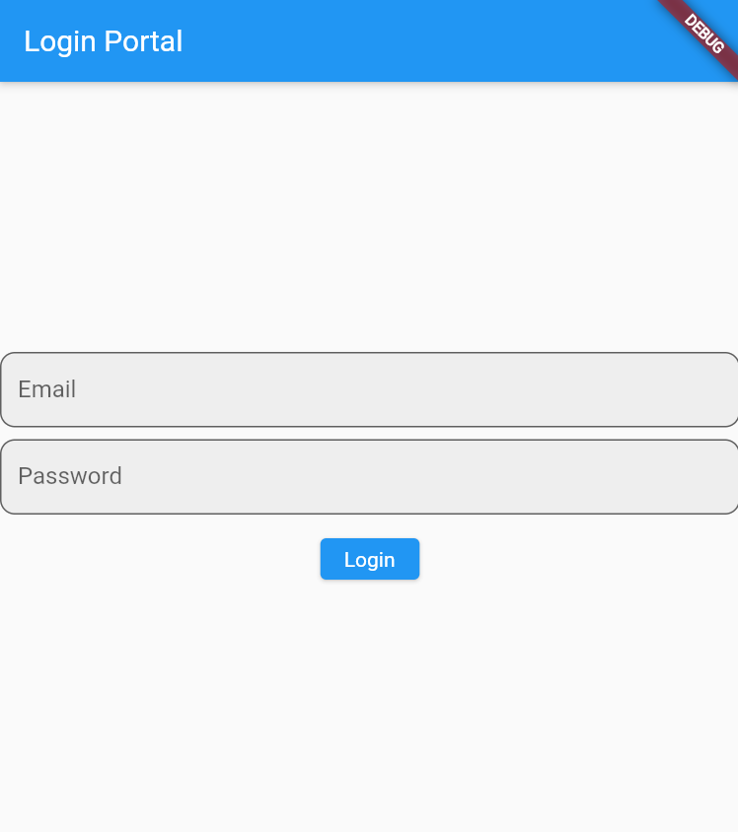

**3. Employee Portal:**

The Employee Portal is tailored for employees to manage their leave requests. Employees can seamlessly submit leave requests through an intuitive interface. Once a request is submitted, the relevant information is stored in Firestore, ensuring a centralized and easily accessible record of leave requests.

**4. Admin Portal:**

The Admin Portal provides administrators with the tools to review and manage leave requests. Admins can efficiently approve or disapprove requests, and these decisions are instantly reflected in the Firestore database. The portal offers a comprehensive overview of leave requests, allowing administrators to make well-informed decisions.

**5. Firestore Integration:**

Firestore serves as the backbone of the Leave Management System, providing a scalable and real-time database solution. The database is seamlessly integrated, storing user credentials, leave requests, and approval status. This integration ensures efficient data retrieval and storage for a seamless user experience.

**6. Challenges Faced:**

Throughout the development process, challenges were encountered and addressed. These included authentication complexities, data synchronization issues with Firestore, and ensuring a smooth flow between the various components of the application.

**7. Future Improvements:**

Looking ahead, there are opportunities for further enhancement. Future iterations of the application could include features such as advanced reporting for administrators, automated notifications, and additional user roles. Continuous improvement and feedback integration would contribute to the system's evolution.

**8. Conclusion:**

In conclusion, the Leave Management System is a robust and efficient solution for handling leave requests within an organization. The application's secure authentication, user-friendly portals, and seamless Firestore integration contribute to a streamlined leave management process. The project addresses the initial problem statement and lays the foundation for future enhancements and scalability.

**TEAM:**

**JUNAID ALI 20SW066**

**FARHAN ALI ARAIN 20SW072**